Modified CpRh(III) Complex-Catalyzed Ortho Halogenation of O-Phenyl Carbamates (Word Style “Title”, Main Words Should Be Capitalized)
Author’s Name-a,¹ Author’s Name-b,² and Author’s Name-c¹ (Word Style “Author1”)
Author’s Name 2nd Line (Word Style “Author2”) (delete if not needed)
¹Department, Institution, Address Zip code (Word Style “Affiliation”)
²Department, Institution, Address Zip code (Word Style “Affiliation”) (delete if not needed)

Title (Word Style “Title”): authors should capitalize the main words, which are nouns, pronouns, verbs, adjectives, adverbs, and subordinate conjunctions, regardless of the number of letters. Do not capitalize coordinating conjunctions, (and, but, or, nor, yet, so), articles (a, an, the), or prepositions, unless they appear as the first word in the title.
Authors’ Names (Word Styles “Author1” and “Author2”): the name of presenter should be underlined. Do not designate the corresponding author with asterisk. Do not include professional and official titles and academic degrees.
Affiliation (Word Style “Affiliation”): multiple affiliations should be indicated with superior figures (e.g., ¹Depertment of Chemistry, …, OM University, Osaka 550-0004).
Main Text (Word Style “Text_body”) should be concise.
Figures, Schemes, Equations, and Tables should be embedded in the text. Letters and symbols in figures and tables should be large enough to be clearly reproduced. Each item must be given sequential numbers (i.e., 1, 2, 3 …). Word Styles available: “Image”, “Figure_caption”, “Scheme_heading”, “Table_title”, “Table_body”, and “Table_footnote”.
References should be numbered and listed at the end of the manuscript, following the heading “References (and Notes).” The latest format of Chemistry Letters is recommended, but the other formats including the ACS and RSC styles will be accepted. All references should be typed in a uniform format. Word Styles available: “Reference_heading” and “References”.

Examples

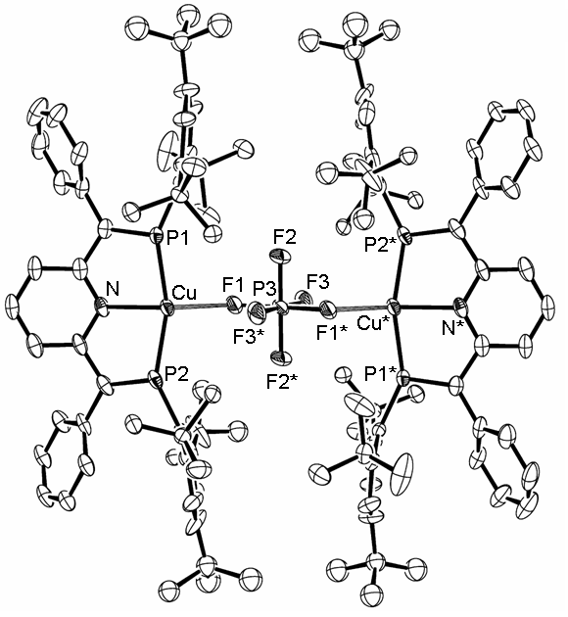
Figure 1. ORTEP drawing of 1 with 50% probability ellipsoids. Hydrogen atoms are omitted for clarity. Selected bond distances (Å) and angles (deg): Cu–N = 2.097(3), Cu–P1 = 2.2613(10), Cu–P2 = 2.2638(9), Cu–F1 = 2.241(2), P3–F1 = 1.637(2), P3–F2 = 1.586(2), P3–F3 = 1.588(2), N–Cu–F1 = 144.32(9), P1–Cu–P2 = 157.34(4), N–Cu–F1 = 144.32(9), Cu–F1–P3 = 128.95(13).

Scheme 1
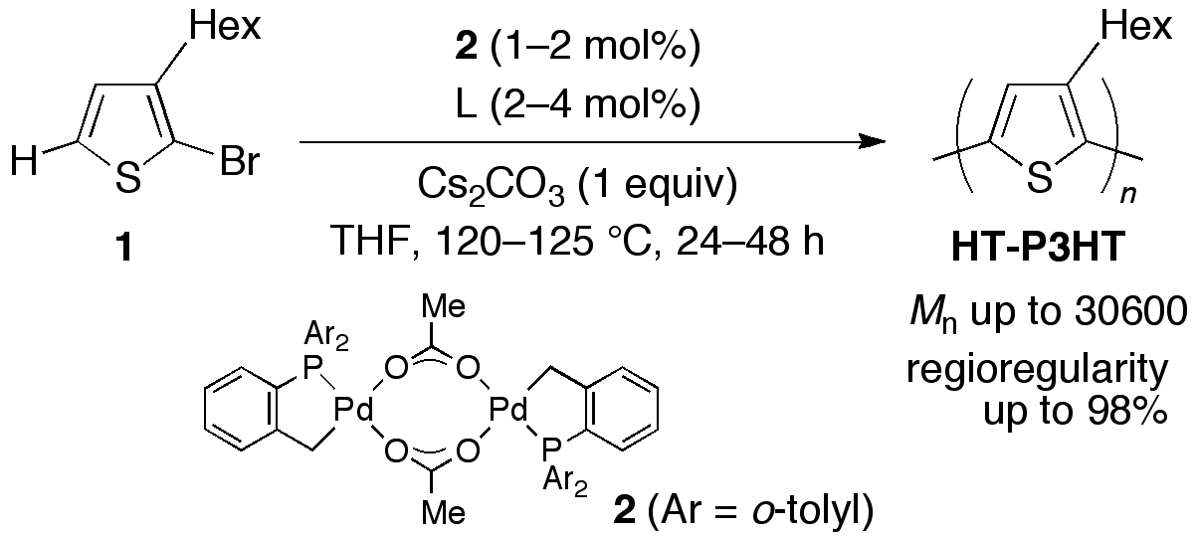

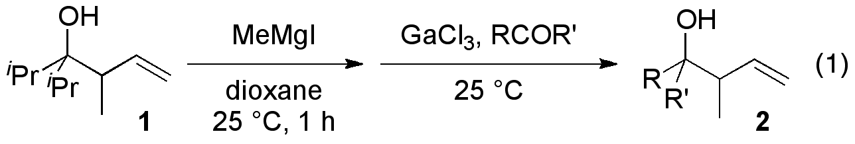

Table 1. Example of Table Formatª
entry substrate time (h)^{b} product yield (%)^{b}
1 1a 1 2a 20
2 1b 2 2b 40
3 1c 3 2c 60
4 1d 4 2d 80
5 1e 5 2e 100
ªThis table is formatted with tab stops. ^{b}The other styles of unit indication (e.g., time/h, time [h]) will be accepted.

Table 2. Example of Table Formatª
entry | substrate | time (h)^{b} | product | yield (%)^{b}
1 | 1a | 1 | 2a | 20
2 | 1b | 2 | 2b | 40
3 | 1c | 3 | 2c | 60
4 | 1d | 4 | 2d | 80
5 | 1e | 5 | 1e | 100
ªThis table is formatted with table tools. ^{b}The other styles of unit indication (e.g., time/h, time [h]) will be accepted.

References
1 a) R. D. McCullough, R. D. Lowe, J. Chem. Soc., Chem. Commun. 1992, 70. b) T.-A. Chen, R. D. Rieke, J. Am. Chem. Soc. 1992, 114, 10087.
2 a) T. Yokozawa, A. Yokoyama, Chem. Rev. 2009, 109, 5595. b) E. E. Sheina, J. Liu, M. C. Iovu, D. W. Laird, R. D. McCullough, Macromolecules 2004, 37, 3526. c) A. Yokoyama, R. Miyakoshi, T. Yokozawa, Macromolecules 2004, 37, 1169.
3 a) T. Satoh, M. Miura, Chem. Lett. 2007, 36, 200. b) D. Alberico, M. E. Scott, M. Lautens, Chem. Rev. 2007, 107, 174. c) L. Ackermann, R. Vicente, A. R. Kapdi, Angew. Chem. Int. Ed. 2009, 48, 9792.
4 a) M. Sévignon, J. Papillon, E. Schulz, M. Lemaire, Tetrahedron Lett. 1999, 40, 5873. b) J. Hassan, E. Schulz, C. Gozzi, M. Lemaire, J. Mol. Catal. A: Chem. 2003, 195, 125.

